**Readme file for Ex6-5 STK scenario**

This STK scenario executes an ascending node only transfer. There is only the book example hardcoded example included.

1. SatInit and SatFinal are used in the hardwired maneuver example.

2. SatIter is a more generic inclination only change scenario. It uses the Astrogator targeter and iterates to arrive at the end condition. This option is more generic for examining various cases in which an ascending node only change is needed.

In a more generic case, the parameters are setup in a targeting sequence which iterates to find the solution. The overall sequence is as follows.

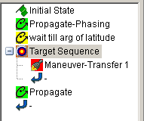

The propagate and events are as before, but the maneuvers and targeting require additional explanation.

The targeting sequence handles the iteration.

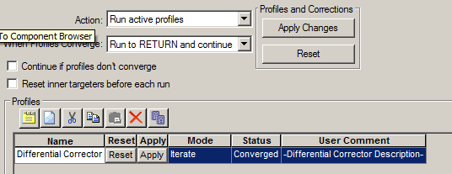

Also important here is to select the final values for the end states. It’s under the properties tab. We’ll discuss each of these values further on the particular maneuvers. For now, only the equality constraints will be used. The remaining values are filled in once the sequence is setup and run.

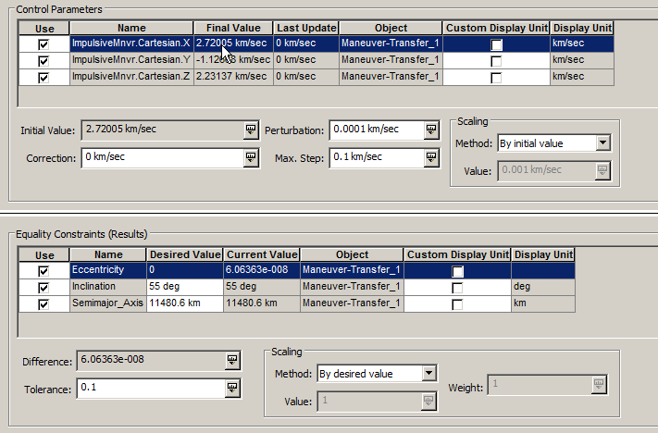

For the first maneuver, we want to enter the transfer orbit and target. Notice the check marks on the 3 components of the velocity – that’s necessary so they can all be targeted in the iterations.

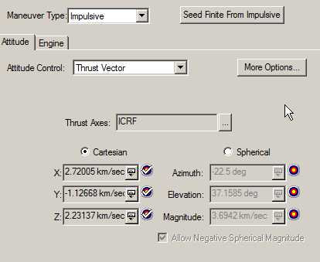

The Results button on the page is very important as it specifies what parameters can be targeted during that maneuver.

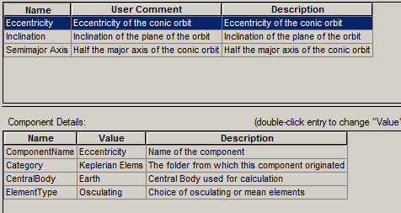

xxxThe propagate in the middle simply tells the orbit it must go until apogee is reached. Notice there is no iteration on this as it must get to apogee.

The next maneuver is required to circularize the orbit. Notice that all 3 components of the maneuver are checked here. Thus in the iterations, the targeter will iterate on all 3 components of the two maneuvers (total of 6).

The Results section is again important since values are to be targeted in this segment. Note that these parameters will likely differ from those on the first maneuver, but are kept aligned with each maneuver in the targeter.

We then propagate for a day in the final orbit.

Since we have to target, we run the mission sequence button () and find the following. Notice that the 6 maneuver components are grouped (1st, then 2nd).

